Unit 8 Vocabulary

The vocabulary for this unit comes from chapter 14 (page 494) and chapter 16 (page 574) in the textbook. Using only the textbook, look up each of these terms, read about them in the textbook, then define, illustrate and explain in your own words. Draw four columns in your composition notebook for each section, for example:
Term | Definition | Explanation (in my own words) | Drawing
Pressure | Force distributed over an area | Every time air molecules collide with a surface | 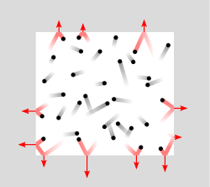

Vocab terms:
- Concentration
- Rate
- Collision Theory
- Catalyst
- Activation Energy
- Reaction Rate
- Reaction Coordinates
- Chemical Equilibrium
- Equilibrium Constant
- Le Chatlier’s Principle
- List all of the factors that affect reaction rates (pressure, temperature, and concentration), explain how each factor affects the rate of a reaction and draw a picture for each.

